Annual Volume

T H E

*of*

L A W S

*of the*

7estern Region of Nigeria

19 5 8

***containing***

THE LAWS OF THE WESTERN REGION OF NIGERIA

**AND SUBSIDIARY LEGISLATION MADE THEREUNDER**

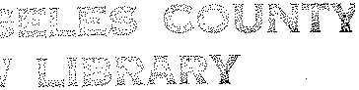

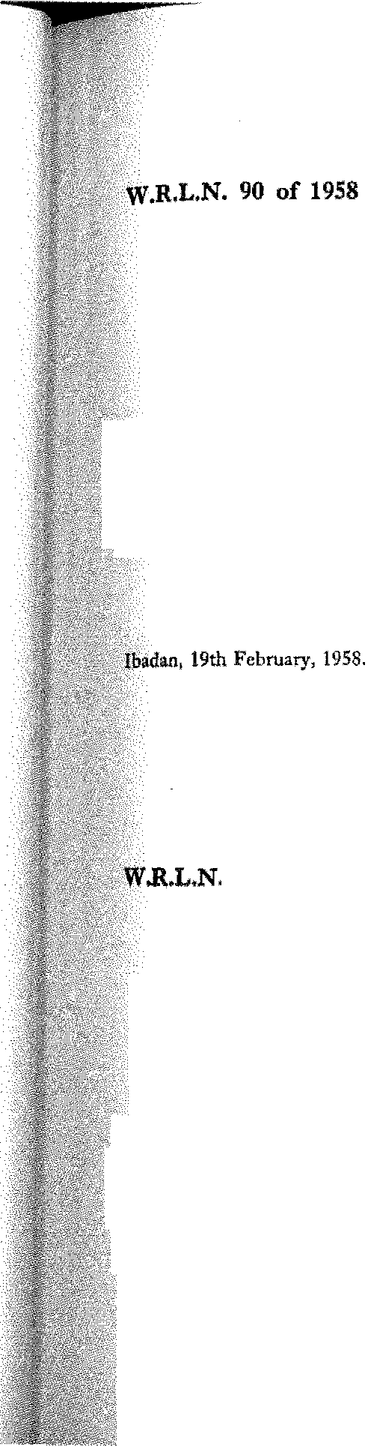

***B 93***

## The Local Government Law, 1957

*(No. 12 of 1957)*

THE CONTROL OF DRUMMING ADOPTIVE BYE-LAWS ORDER, 1958 : EGUN-AWORI DISTRICT COUNCIL

DATE OF COMMENCEME'.'<T : 13TH MARCH, 1958

**Notice is hereby given that ln exercise of the powers conferred upon the**

/ J1gun-Awori District Council by sections 82 (2) and 271 of the Local Govem­

**-;;}\rnent Law, I957, the EgunAwori District Council in accordance with section**

'''8:2{3) ***(a)*** of the said Law has resolved at its meeting held on the 28th day of

i:December, 1957, that the Control of Drumming Adoptive Bye-laws, 1956, **W.R.L.N.** ll

:> be adopted. of 1956.

D. A. MURPHY,

### Permanent Secretary 1

*}',,finistry f Local GQ'IJernment*

**91 of 1958**

## The Local Government Law, 1957

*(No. 12 of 1957)*

THE REGISTRATION OF BIRTH AND I;EATH ADOPTIVE BYE-LAWS ORDER, 1957 : IJERO DISTRICT COUNCIL

DATE OF COMMENCEMENT : 13TH MARCH, J9S8

**:Sotice is hereby given that fo. exercise of the powers conferred upon the**

. )jero District Council by sections 82 (2) and 271 of the Local Government

(Law, 1957, the Ijero District Cuocil in.accordance with section 82 (3) (a) of

::the said Law, has resolved at 1to meeting held on 5th October, 1957, that

:·,: \'the Registration of Birth and Death Adoptive Bye-laws Order, 1956" be W.R.L.N. IS

''. adopted. of 19S6,

W. S, SMITII,

### Permanent Secretarv

1

*Ministry of liealth and Social Welfare*